 |  | Amgylchedd ac Isadeiledd / Environment and Infrastructure
 |  | Pennaeth Gwasanaeth / Head of Service - Geraint Edwards, BEng(Hons) CEng FICE
Swyddfa’r Harbwr, Y Cei, Conwy, LL32 8BB
Harbour Office, The Quay, Conwy, LL32 8BB
www.conwy.gov.uk/harbourandseaboard

Local Notice to Mariners 13/2019

All mariners please be advised that an aerobatic display will be taking place in Colwyn Bay on 5th October 2019. The display window is between 1500-1800 local time (BST). All vessel are requested not to enter the display area during this period. The display area is marked with a red boundary on the map below. Two guard vessels will be in attendance to the east and west of the display area.

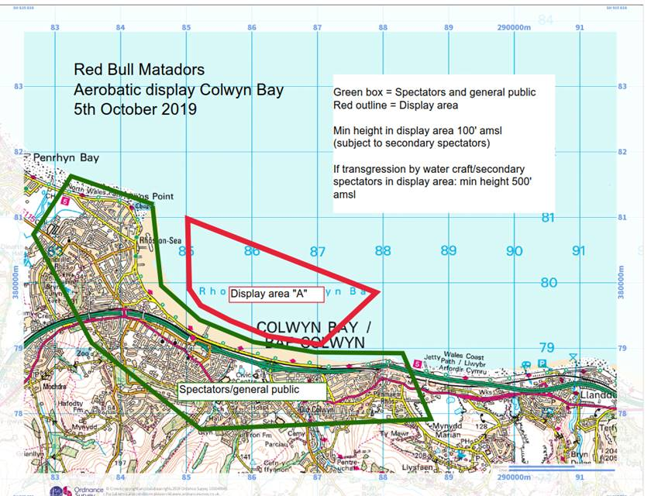

Matthew Forbes
MSc LLB (hons) BSc MNI
Conwy Harbour Master

 | Prif Switsfwrdd / Main Switchboard: 01492 574000  www.conwy.gov.uk  Ni ddylid cyflwyno dogfennau llys drwy ffacs  Fax not to be used for serving proceedings | 

