EIA Screening Opinion
  - Open Water sub surface Shellfish Cultivation
James Wilson | Director, Deepdock Ltd | May 2021

- A description of the whole project, including working methods

This request for screening opinion is being submitted by Deepdock Ltd, of Bwthyn Y Mor, Llanfaethlu, Holyhead LL65 4HD to determine whether an Environmental Impact Assessment under the Marine Works (EIA) (amended) Regulations 2017 is required in relation to the works proposed. Deepdock Ltd are proposing to undertake at scale extensive cultivation of bivalve shellfish, principally mussels – Mytilus edulis in 3 stand alone sites: (1) Puffin East (2) Conwy Bay Spoil Ground (3) Adjacent to Gwynt Y Mor. Total area covered within these proposals is 991 ha.

The proposal to be submitted is that up to a maximum of 100 subsurface shellfish lines are deployed in each of the three identified areas. This deployment, when complete, will enable the collection of seed mussel, thinning of seed density on ropes and reattachment to grow out the animals point of market acceptable size and condition. Any mussel seed collected on the ropes that exceeds the reattachment needs will be used on the seabed cultivation areas within the Menai Strait.

Each of the three sites could produce up to 300 tonnes of mussel seed and up to 2000 tonnes of market ready mussel per year.

Collaborative work and research undertaken by Deepdock Ltd with Bangor University over the period from 2014 – 2020 within a 6.5ha experimental area to the East of Puffin Island underpins this proposal.

Site 1: East of Puffin
The proposed Site East of Puffin Island (see figure 2) covers an area of 384 ha and encompasses a disused spoil dumping ground to the South East of Puffin island. The area coordinates are as follows:
53.3231330 | -4.0109330
53.3286670 | -4.0002830
53.3269500 | -3.9698500
53.3181192 | -3.9840322
53.3118287 | -3.9734752
53.305058 | -3.9852098

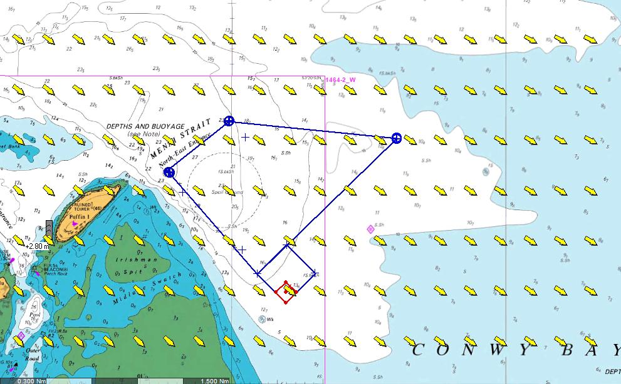
Figure 1 Plot of the proposed site (1) East of Puffin Island in Conwy Bay. The existing leasehold area(highlighted in red) held jointly between Deepdock and Bangor University can be seen in in the bottom NW corner of the larger proposed site.

Site 2: Offshore Spoil
This area encompasses the much larger, but also disused spoil dumping ground to the North West of Puffin island. The area has dimensions of 2000m * 2400m and is 480ha in total. Whilst in a more exposed area to site 1, the area shares many of the same characteristics. It has a deeper water profile with low water depths of between 25-30m within the area identified which provides for additional flexibility in terms of deployment of cultivation equipment. It is an area that is subject to moderate wave energy & slightly higher current velocities but is similar to the characterisitics evident in site 1.
The area proposed is described by the following coordinates:
53.3598170 | -4.0541830
53.3773000 | -4.0372330
53.3878170 | -4.0715670
53.3715670 | -4.0876000

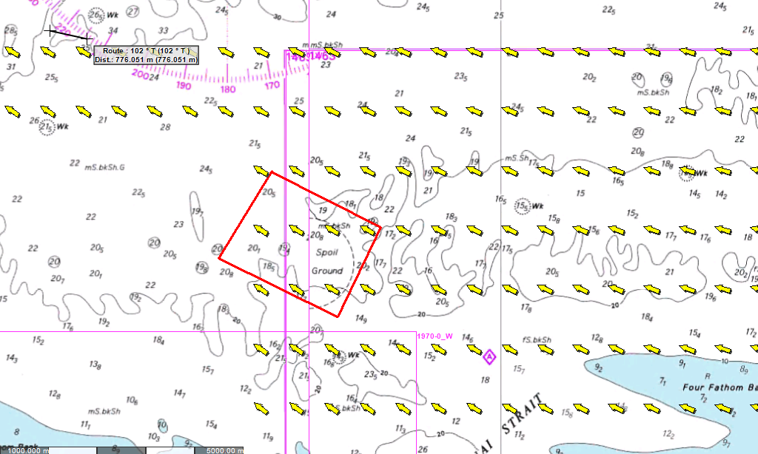
Figure 2. Plot of the proposed site (2) at the offshore spoil ground North West of Puffin Island in Conwy Bay.
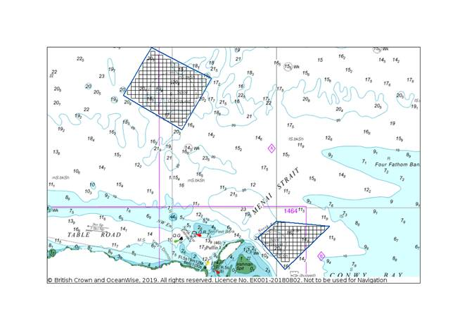

Site 3: South West flank of Gwynt Y Mor Windfarm
The coordinates that describe the proposed area are found below. IN total the size of the proposed location extends to 127ha. The size, shape and extent of the area identified is the result of a long standing dialogue between Deepdock Ltd and the operators of the Gwynt Y Mor Offshore Windfarm (Innogy Ltd)
Seabed characteristics are typical of those found elsewhere within the locale; circalittoral sand and sandy mud. Depth profile lies between 15-18m with a prevailing current regime that runs East/West

PointID | Latitude | Longitude
1 | 53° 26.017' N | 3° 40.469' W
2 | 53° 25.983' N | 3° 40.262' W
3 | 53° 25.991' N | 3° 40.035' W
4 | 53° 25.920' N | 3° 39.848' W
5 | 53° 25.807' N | 3° 39.744' W
6 | 53° 25.724' N | 3° 39.597' W
7 | 53° 25.664' N | 3° 39.374' W
8 | 53° 25.653' N | 3° 39.156' W
9 | 53° 25.522' N | 3° 38.816' W
10 | 53° 25.441' N | 3° 38.710' W
11 | 53° 25.380' N | 3° 38.578' W
12 | 53° 25.252' N | 3° 38.535' W
13 | 53° 25.122' N | 3° 38.402' W
14 | 53° 25.283' N | 3° 39.243' W
15 | 53° 25.411' N | 3° 39.837' W

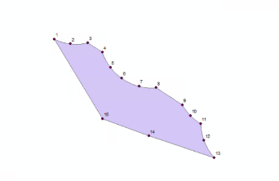

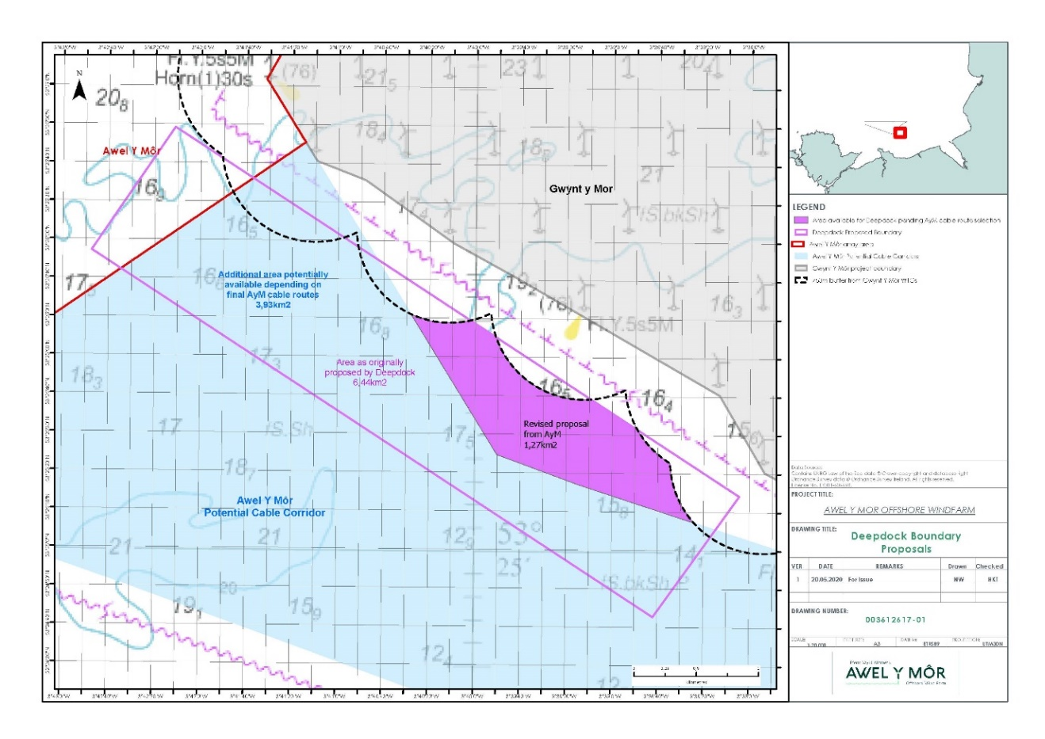
Figure 3: Area shaded purple has been agreed by Innogy and Deepdock Ltd as possessing the appropriate characteristics necessary for open water cultivation AND also not conflciting with any works associated with the Gwynt Y Mor OWF nor the Awel Y Mor proposed OWF
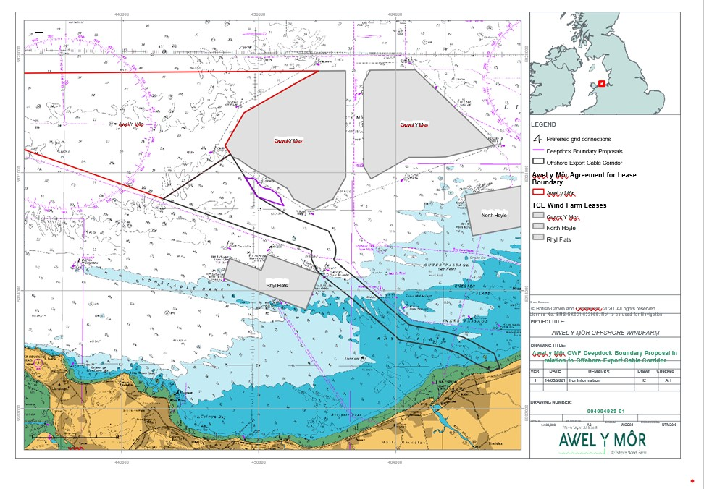

The cultivation system
Installation of the Sub Surface Longlines system.
Each system is 250m in length, with 150 m headline holding up to 1500m of growing medium, with 50m at either end leading up from the screw anchors embedded into the seabed (figure 4).
An individual longline consists of a pair of direct embedment helical screw ‘Alpha Anchors’ set 250m apart (Figure 2) and connected to 25m of synthetic fibre risers (36mm seasteel™ rope) to minimise the environmental impact on the seabed. Risers connect to 150m of tensioned 36mm seasteel™ header lines positioned in parallel and suspended 2m below the water surface. Each headline supports 1500m of continuous looped mussel rope, each loop extends to 10m depth with a 1m spacing width between each.
Growing headline is set 2-4m below the surface as this helps to reduce the stress load placed on the system from environmental sources, such as wind, waves and currents

Figure 4 : Sub surface long lines and helical screw anchors
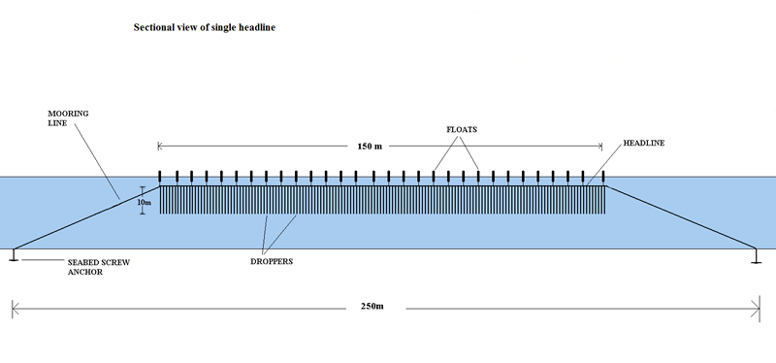
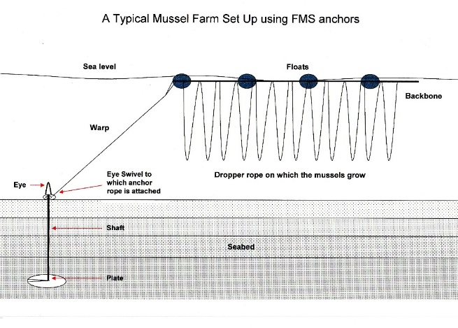
Aside from the navigation aids visible Surface flotation is variable throughout the year depending on production state but includes 250L black offshore mussel farm Pencil buoys (Offshore Shellfish Ltd), 250L Offshore mussel farm cushion floats (JFC Marine) 40L orange submersible offshore mussel farm floats (JFC Marine).
Culture operations
Rope is attached to the deployed headline, this can either be a continuous flow media – a single piece of rope which descends 10 m below the headline and coils back up to the headline repeatedly along the length of the headline – with spacing of 1m between each headline contact – or single dropper lines, a single piece of growing rope individually lashed onto the headline every 1-1.5 m. Harvesting of the mussel, seed or market mussel from the deployed growing line(s) is undertaken on board vessel and all growing rope is cleaned and made ready for next deployment. Rope has an expected working life of 10 years.
A number of lines in each site will be directed toward the collection of shellfish seed, in order to maximize the efficiency of this process, these lines will be deployed with rope that has a higher level of surface area. As a broadcast spawning species, planktonic mussel larvae is evident within the Irish sea throughout the year , although with higher densities occurring at times that correlate with the spawning cycle
When the settled mussels reach 25mm, the ropes are stripped of the fast growing seed mussel. These are then re-attached to a new rope at lower densities to reduce the inevitable density dependent mortality effects that occur through the process of ‘socking’ – the animals are tubed onto the new rope confined within a biodegradable cotton sock. This allows the mussels time to establish a new bond with the rope through byssal attachment before the sock fully biodegrades

Helical Screw Anchors
Key to the environmentally sensitive deployment of the sub-surface shellfish cultivation equipment are helical screw anchors. Helical screw anchors have been utilised in areas of high environmental sensitivity, for some time to deploy moorings for vessels. There use in shellfish aquaculture is more recent. Anchors are inserted into the seabed using a specialist rig which is lowered to the seabed. A mooring rig is lowered down to the seabed where it is attached to the helical anchor which is screwed into the substrate hydraulically. The whole installation is undertaken remotely via hydraulic controls with underwater monitors from the deck of the contracted vessel without any need for divers during this part of the installation.
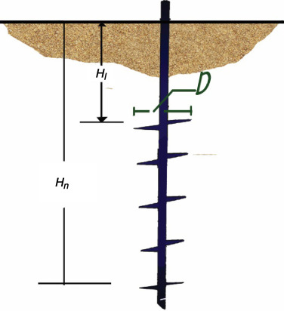

This process is reversed when the anchors are extracted from the seabed. To remove the anchors from the seabed, for redeployment or during site decommissioning the hydraulic drive is simply reversed and the anchors can be easily removed.
The process of deploying helical screw anchors for aquaculture is helpfully illustrated in some film to be found on the You tube channel - though this film is from California – it shows the scale of the operation.
Good information on the substrate is required. DD and BU have undertaken some collaborative work into developing the necessary. The helical screw anchors are easily deployed in sand and sandy mud type substrates, but not easily within hard or rocky deabed types. The EMODnet portal provides good discrimination in terms of the dominant seabed habitat types
All operations associated with the deployment of seabed anchors can be undertaken using a small vessel. For example, the Alysee ( below) is used to deploy such anchors within the UK’s existing open water shellfish cultivation farm in Lyme Bay
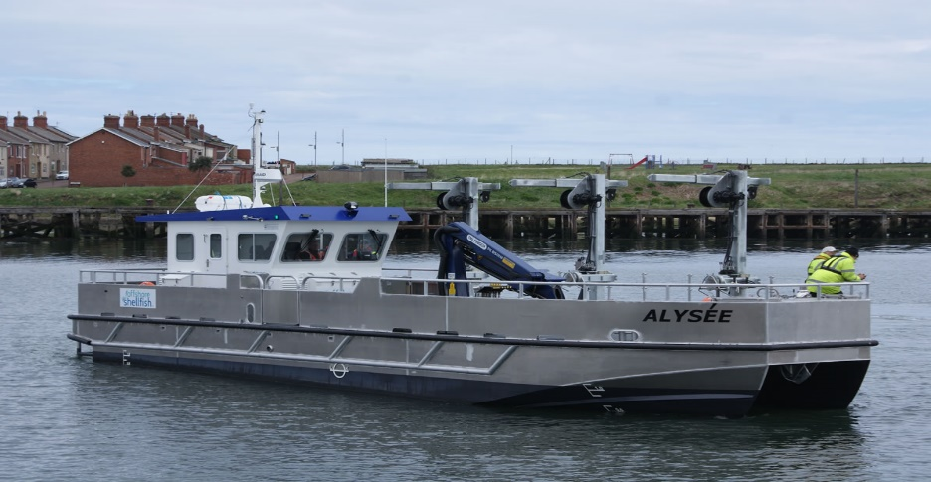
The Alysee is a 15.2m offshore shellfish workboat that works within the Lyme Bay offshore shellfish Ltd area. Screw anchors on each of the proposed sites would be deployed using this vessel
Screw anchors eliminate seabed anchor drag. The unit is directly screwed into the sea floor, disturbing less than 0.3m² of seabed during installation and operation within in sand/sandy mud/muddy sand substrate – the dominant substrate type within the three areas within this proposal. With superior vertical holding power, the lead rope is directly connected to the headline and placed under tension. By doing this, the requirement for chain is extracted, thus eliminating the prospect of any chaffing of the seabed and wider damage caused around the anchor. Screw anchors provide an environmentally friendly option. They have proven holding capacity . Our existing experimental site has been in situ during the most extreme weather events (Hurricane force winds over spring tide High waters) - the structural integrity of the deployed equipment has not diminished.
The mooring line is attached to the head of the screw anchor, through the eye, which protrudes some 20cm above the seafloor. This extends up to the headline. Once the headline is attached at both ends the headline is then put under tension to provide a level of tensile strength within its structure that reduces the degree and extent of any bowing during the daily tidal and current cycle.
Headlines will be populated with growing medium – for the collection of the free floating pelagic planktonic bivalve spat from the water column; or for the on-growing of the animals.
Unlike shellfish long line operations found within sheltered sea lochs / Fjordic inlets / Rias – the open water / offshore systems are exposed to a range of highly dynamic environmental variables, such as wind and current shear. Open water locations are more often highly mixed and less prone to stratified water structures. Where long line systems in sheltered areas are often found separated by 10-15m on one perpendicular, in the open water locations this separation is much greater. Within the first stage deployment it is envisaged that lines will be separated by 100 m from one another.

- Description of location, with regard to the environmental sensitivity of the area.
All sites referred to within this screen opinion application are in the North of Wales, falling within the shadow of Ynys Mon and the NE Wales Coastal strip. As the figure below illustrates, very significant proportions of the entire Welsh marine zone occur under the framework of one or more forms of environmental protection
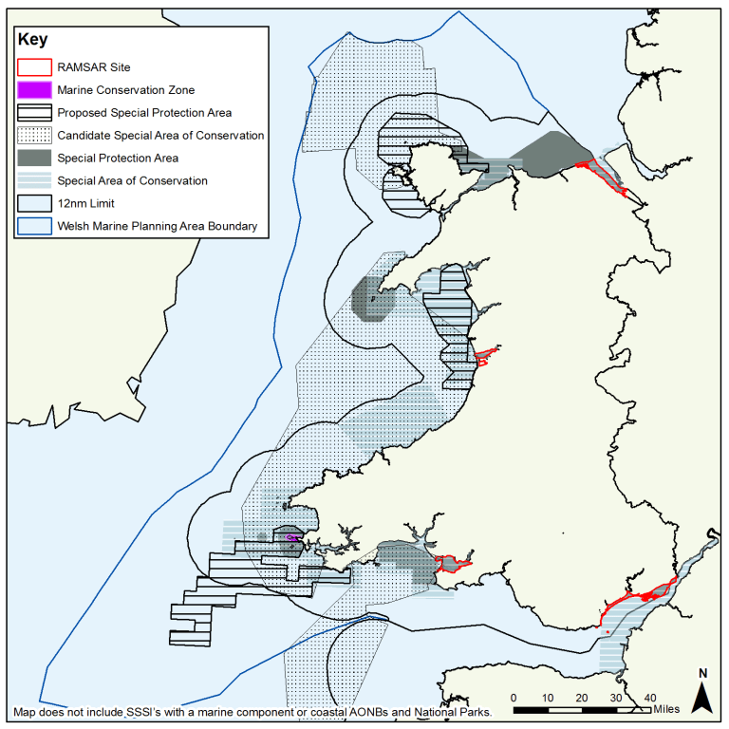

Figure 1 : Welsh marine zone with conservation designation described
(Welsh Government (2016))
All sites identified within this application lie both within and also adjacent to existing Natura 2000 designated areas.
Site 1: East of Puffin – lies within the boundaries of the Menai Strait and Conwy Bay SAC & the Liverpool Bay SPA, adjacent to the Ynys Seiriol SPA and within proximity of both the Anglesey Terns and Traeth Lafan SPA’s
Site 2: Offshore Spoil – lies within the boundaries of the Menai Strait and Conwy Bay SAC, the Liverpool Bay SPA, the Anglesey Terns SPA and within proximity to the North Anglesey Marine SAC
Site 3: Adjacent to Gwynt Y Mor – lies within the boundaries of the Liverpool Bay SPA
Any project proposed must be assessed for the possibility of impact, on the basis of likely significant effect, on all protected features and species and in combination with other projects. Appropriate assessments in this respect will be provided within the full marine licence application.

List of European Marine sites potentially impacted by the proposal

Site Name | Site number | Site size | Site type
Menai Strait and Conwy Bay / Y Fenai a Bae Conwy | UK 0030202 | 26501.4 ha | SAC
Liverpool Bay / Bae Lerpwl | UK9020294A | 252757.3 ha | SPA
Anglesey Terns / Mowenolian Ynys Mon | UK9013061 | 101931.1 ha | SPA
North Anglesey marine / Gogledd Mon Forol | UK0030398 | 324949 ha | SAC
Lafan Sands / Traeth Lafan | UK9013031 | 2703.13 ha | SPA
Cardigan Bay / Bae Ceredigion | UK0012712 | 95857.06 ha | SAC

- Descriptions of the aspects of the environment likely to be significantly affected by the project.

The activity described within the proposal, shellfish cultivation, occurs within the water column though is also reliant on the firm and secure anchorage in the seabed. As such potential effects may occur within three parts of the marine – surface, within the water column and the seabed.

Determination as to whether any of these elements of the marine scape are ‘likely to be significantly affected by the project’ will therefore be factored on the information provided as to the impacts of the shellfish cultivation equipment on the different parts of the sea, within the vicinity of the sites proposed.

Sea surface
The applicant is aware that the principle protected species within the Liverpool Bay SPA – common scoter duck – Melanitta nigra – is easily put to flight . It is often thought to be adversely affected by high levels of marine traffic, and is usually found in largest abundances in areas that have suitable environments and low ship movements. However there is also strong evidence to suggest that the bird can habituate to areas that are more intensely transited. Whilst the location of site 3 is identified as being within areas of high concentrations of the overwintering species, these are also locations of very frequent fast vessel transit associated with the operation of the Gwynt Y mor offshore windfarm and the development of the Awel Y Mor site. Sites 2 has much lower abundance estimates, where site 1 has been identified as being on the edge of areas of high abundance of this overwintering species.
Common scoters are known to be haphazard feeders, although ones with a preference for small bivalves. The offshore cultivation ropes with a crop of mussel evident on them may possibly be targeted as an additional source of food by the species.
Vessel operation in each of the proposed sites are likely not to exceed one day per week in each area. Vessels engaged will be relatively slow moving (<10 knots). Operation of the areas will require frequent (weekly) access to each site by vessel – to monitor rope condition, to optimize floatation buoyancy of lines, in addition to mussel seed stripping, thinning and harvesting.

Deployment of the equipment might have a potential impact on other marine users, such as leisure, commercial fishing and other large marine vessels. All Sites have been identified to minimize adverse interaction with forms of commercial fishing activity. All sites will be clearly and appropriately marked in accordance to direction from the Marine and Coastguard Agency and Trinity House.
Sites 1 and 2 are located close in to shore – within 3nm of the coast and inside the 30m depth contour. As such, unless on passage to and from the Menai Strait, large marine vessel traffic avoids such close inshore areas. However some 2nm to the north west of site 2 is the established deep water moorings off Moelfre for large and very large vessels transiting to and from the Port of Liverpool.

Seabed
The proposal will effect on the seabed in two ways. Firstly through the deployment of the screw anchors directly into the seabed –the process is described elsewhere within this document; Secondly through any detritus / psuedofaeces drop off and/or shading as a result of the ropes in the water column

The cultivation of naturally occurring bivalve shellfish is widely acknowledged as the most environmentally benign form of producing animal based protein. As low trophic species, bivalves filter feeding molluscs, mussels extract all of their nutritional requirements from the particulate matter that occurs in the environment that surrounds them.

.It has been established that during the course of this natural behaviour, mussels and other bivalve filter feeding animals are able to contribute to the wider environmental bioremediation of carbon, and excess phosphates and nitrates, which emanate from terrestrial agriculture systems, by assimilating these elements within their flesh or within the structure of their shells

For the systems described within this proposal, the environmental footprint can be framed within two broad areas – (1) the spatial extent of the areas, the direct impact of the anchoring systems; and issues associated with any biological matter impacting the seabed; & (2) the effect of the gear when deployed on other species within the ecosystem – such as any risks of entanglement, shading on the seabed, carrying capacity and competition for food.

Appropriate design & spacing of the structures will ensure that the risk of adverse effect on environmental features is minimized. Current and on-going research suggests that the overall effects of developing subsurface cultivation of bivalve filter feeding organisms such as mussels could have beneficials outcome on ecosystems, in terms of bioremediation and through the developments of temporary artificial reefs.

- Description of any likely significant effects of the project on the environment, on such effects resulting from: expected residue and emissions and the production of waste; use of natural resources, in particular soil, land, water and biodiversity

The proposal to undertake open water cultivation of bivalve molluscs – such as Mussels and Scallops - is unlikely to impose any significant adverse effects on the environment.

Nevertheless there are a number of elements of the project that, from a layman’s perspective, might be considered as presenting such risks. These are outlined below

Ecological
Mussels (Mytilus edulis) are a native species, a naturally occurring filter feeding bivalve. They are common and widely distributed around the coastline of the British Isle. Collection/settlement of juvenile mussel (spat) and the on-growing / cultivation on the sub surface shellfish systems, requires no inputs to the environment beyond the deployment of the cultivation equipment.

Carrying capacity
Mussels are highly efficient and effective filter feeding organisms. IN natural environments, it is recognized that all forms of aquaculture that rely on natural capacity for the provision of food or water flow and the provision of other environmental variables, the carrying capacity of the area is of high concern.

Open water environments are more exposed and more dynamic, more mixed and less likely to be subject to stratification of the water. If located in areas of good primary productivity, the effects of mussel cultivation on food availability to other organisms in the nearby ecosystems is negligible. All sites identified within this proposal are located within proximity to the wider Liverpool Bay zone, which is well established as an area of particularly high primary productivity within the Eastern Irish sea.

A close equivalent to the open water shellfish cultivation area within this proposal is the mussel cultivation within the Menai Strait East Fishery Order. This Fishery order encompasses some 700 ha in the Menai Strait. Seabed cultivation is practiced here as opposed to taking advantage of the sea column, it is one of the primary shellfish cultivations location in the UK with production levels of between 7500 – 10000 tonnes / year (depending on sufficient mussel seed inputs). The area is subject to twice daily tidal inputs of food laden water, with intermingling of water moving up from the south being generally overwhelmed by water pushing in from the Liverpool Bay. Research undertaken by Bangor University has demonstrated that the effect of significant quantities of mussel biomass within this confined space has very little discernible effects on the carrying capacity of the wider ecosystem.

Organic waste production
Mussels, in common with other bivalve molluscs, are filter feeding animals. That is they ingest food, through an inhalant syphon, from the environment that surrounds them. That particulate matter which is of nutritional value to the animals they utilize, that which is not, they excrete. To avoid reingestion of the same particulate matter over and over, when material that mussels excrete is bound up within some mucus, thereby making the excreted material both larger and denser than when it was ingested. This mucus bound material is known as psuedofaeces

IN more sheltered cultivation areas, this excreted material can sometimes fall to the seafloor underneath the longlines, building over time into a layer of anoxic mud. Indeed in seabed cultivation, it is this mud, known as mussel mud, that provides the stable layer that enables the cultivated mussels to be harvested without any damage occurring to the base seabed.

However, in more open water environments, subject to more dynamic natural forces, such as currents and the effects of waves, the psuedofaeces material breaks up and reverts to the wider natural seston. Work to date within the BU experimental site, and indeed findings from similar open water shellfish cultivation elsewhere in the UK and further afield, confirm that there is no discernible build up of material within the vicinity of open water shellfish cultivation locations.

Biosecurity – Invasive Non Native Species (INNS)
Aquaculture is often and accurately noted as being one of the principle vector activities for the introduction of invasive non native species or locally absent species into new areas. There are several qualified instances of this occurring within the Welsh marine area; for example, the inadvertent transfer of slipper limpets – Crepidula fornicata – in 2008, which was followed by extensive, rapid and successful eradication efforts and led directly to the joint development of the Bangor Mussel Producers Code of good practice, with the Countryside Council for Wales. However this is often not the straightforward issue that it is assumed to be. Currently the focus of Government is directed at the use of non indigenous oysters into UK ecosystems. However Crassostrea gigas and Tiostrea chilensis were both introduced by UK Government in the late 1960’s and early 1970’s and allowed to become feral. This is often overlooked.

However a major vector route for introduction of INNS / locally absent species is through commercial and recreational shipping, which ascidians such as Styela clava and Didenmun vexillium both introduced into Welsh Waters through this route.

An ongoing Horizon 2020 project ‘ECOSTRUCTURE’ considers in part the likely effect and adaptation of invasive spec to climate change. IT investigates the potential for new offshore infrastructure such as Offshore Wind farms and associated substations, to become so called stepping stones within the sea. Stepping stones is a way of describing new structures in the sea that might provide certain NN flora and fauna with a mid way refuge within areas separated by substantial sea zones.

The proposal in all sites is predicated around the cultivation of native bivalve molluscs, principally the common mussel, Mytilus edulis, however also both the king and queen scallop – Pecten maximus & Aquipecten opercularis - have commercial potential within open sea cultivation systems. All mussel seed will be collected within the proposed sites, through the use of spat collecting rope, rope with a higher surface area, deployed at the biologically optimal time. As such no non-native species (NNS) will be introduced into the locale via the process of open water shellfish cultivation

The open water subsurface shellfish equipment is unlikely to fulfill the characteristics of a stepping stone for INNS due to the rapid cultivation cycle anticipated within the open sea areas – based on the experience of the experimental area. Although the headline and the anchor rope will be fixed into position, the headline will be subject to deployment and stripping of biomass over a relatively short cycle. Any mussel seed settlement on spat collecting rope will be removed 2-3 months after settlement and re-socked onto growing medium rope. This rope will be in the water for 10 months prior to harvest – a process that relies on the stripping off of all growth and cleaning of rope.

Marine mammal interactions – Displacement and Entanglement
The potential for marine mammals, such as cetaceans to become entangled within shellfish cultivation equipment has been much discussed. For those species that have strong physiological echo location capabilities, this risk is reduced. For those species that rely more on sight, then the risk of adverse interaction is elevated.

The cultivation areas proposed remain ‘open’, there is no requirement for predator netting as might be seen on at sea fin fish aquaculture sites, and with lines deployed separated by 100m, displacement of foraging or migratory cetaceans should be minimized.

One of the main approaches to reduce the risk of entanglement is through the appropriate siting of cultivation area. ON the basis of available evidence, for the larger marine mammals known to transit within the Irish sea, migration routes lie offshore form the areas proposed within this application.

Monitoring at the Experimental site has recorded multiple individual sightings of Harbour porpoise (Phocoena phocoena) and Bottlenose dolphins (Tursiops truncatus) – individuals and in pods. Both species seems to congregate around the site as the mussel ropes act as temporary artificial reef structures, with cetacean prey species congregating around the ropes as they feed. There has been no indication of any adverse interaction at the site.

Technological
The Screw anchors deployed at either end of each line hold, once deployed, leave a very minimal surface imprint of only 30cm² / anchor. In each site, with up to 100 sub surface lines proposed – the total area impacted by screw anchors is 100*2. Screw anchors are fixed, have no heavy seabed chain, do not suffer from pull and drag. As such the direct spatial footprint is confined to a few m².

The dominant substrate in each area is described as being circalittoral muddy sand or sandy mud. Parts of Site 1 east of Puffin and the majority of site 2 Offshore spoil – have previously been utilized as areas where waste spoil material from port side developments has been dumped – though both areas have not been used for this purpose for many years. Site 3 adjacent to Gwynt Y Mor has a more homogenous sandy substrate.

- Such other information or representation as the applicant wish to provide, including a description of any feature of the project or measures envisaged to avoid or prevent what might otherwise be a significant effect on the environment

The submission of the full application will incorporate an assessment of the implications of the proposal on the Water framework Directive obligations. Site 1 lies within 1nm of coastal baselines and as such is fully encompassed within the framework of this requirement, sites and lie further offshore (3 & 6 nm respectively) and so must be assessed with reference to any chemical contamination within the context of the WFD.

All sites lie within or adjacent to EMS. The proposal will require the production of appropriate assessments to determine whether there is a significant adverse effect on any of the features of the protected sites on the basis of the best available scientific evidence.

In making this application, substantive reference has been made to key EU texts. In particular the EU produced Interpretation of definitions of Project categories of Annex I and Annex II of the EIA directive (2015). This guidance document was written to assist and inform regulators as to the type and form of proposals that might be found to fall within the scope of the Environmental Impact Assessment Directive. The requirements of the directive have been transposed into UK law and currently is assigned on the statute book as The Marine Works (Environmental Impact Assessment) (amendment) Regulations 2017 . This describes as Annex I and II as Schedule A1 and A2 projects. In this sense interpretations within the guidance document provide relevant direction.

It is clear that the proposal does not constitute an activity that falls within the scope of an Annex I / A 1 project. However in terms of Annex II/ A2 projects the guidance document provides useful insight. The Marine works (EIA) regulation 2017 make reference to Agriculture, silviculture and Aquaculture projects, with sub heading (6) intensive Fish Farming as falling within the scope of an annex II/A2 project. However what constitutes an intensive fish farming activity ?
The EU guidance document makes clear that there is a distinction drawn between what is meant by ‘Intensive Fish Farming’ and other forms of aquaculture. It suggests that for a project to fall within the definition of ‘Intensive Fish Farming’, it should include certain attributes -
Intensive fish farming would imply using techniques designed to increase the
production of the species in question beyond the natural capacity of the
environment or culture stage, up to and including harvesting. Typically, this practice
will involve the input of an additional compound feed to compensate for the lack of
naturally available food at the density at which the animals are farmed. Husbandry
techniques, which are also applicable to non-intensive farming, including the use of
medicines and aeration of the water to meet the needs of the animals and ensure
their health and welfare may also be used -
The extensive cultivation described within this proposal is completely different. Extensive cultivation is wholly based on the principle that the natural environment will fulfil the entire nutritional requirements of the animals being cultivated, so no additional feed will be introduced, thus no pollution from excess feed within the water column. In addition no aeration of the water is required, the offshore locations are all dynamic areas – subject to winds, waves and tides. The dispersal of faeces and psuedofaeces from the cultivated stock and its return into the seston is facilitated through this natural dynamism. No medicinal compounds are used in bivalve cultivation in open systems in any instance.
Indeed the same EU document recognises this scope for confusion and conflation between that considered to be ‘intensive fish farming’ and any ‘aquaculture’ and describes that

“…Algae and mollusc farming are typically extensive forms of aquaculture.”

Whilst the previous legislative architecture has been superseded by the Marine Works (EIA) regulations (2007) (amended) 2017 Regulations – there are some further indications as to a variety of approaches that might be applied to different forms of marine aquaculture and draws a strong distinction between at sea cage cultivation of fin fish and the extensive cultivation of bivalve molluscs.

Previous indications on an interpretation of the distinction between ‘Fish Farming’ and ‘Shellfish cultivation’ can be found in previous legislation, albeit ones which have now been superseded.

For example within the Environmental Impact Assessment (Fish Farming in Marine Waters) Regulations 1999 states :
Interpretation
2.—(1) In these Regulations, unless the contrary intention appears–
“fish farming” means keeping live fish, excluding shellfish, (whether or not for profit) with a view to their sale or to their transfer to other marine waters;

The EIA Regulations make it clear that intensive Fish farming be considered within the framework of an EIA procedure – however it appears to excludes extensive shellfish cultivation from the scope. The rationale behind this is quite clear. Intensive farming of fin fish requires the introduction of multiple inputs – feed, medication and in some cases locally absent species. The extensive cultivation of bivalve shellfish – extensive in the sense that it merely seeks to enhance the natural capacity of the environment through cultivation – introduces no food nor medication into the environment. The scale of the activity has no reference to the respective definitions of what constitutes intensive / extensive aquaculture

https://www.carapax.se/marine-mooring
https://www.youtube.com/watch?v=suyFNiuI4gI
https://www.emodnet-seabedhabitats.eu/access-data/launch-map-viewer/
Offshore Shellfish Ltd https://offshoreshellfish.com/contact-us/
Kaiser M J, Galanidi M, Showler D A & Elliot A J – Distribution and behaviour of Common Scoter Melanitta nigra relative to prey resources and environmental abundance. IBIS 148(s1):110-128
Willer DF and Aldridge DC (2020) Vitamin bullets. Microencapsulated feeds to fortify Shellfish and tackle human nutrient deficiencies. Front. Nutr.7:102 doi 110.3389/FNut.2020.00102
https://onlinelibrary.wiley.com/doi/full/10.1111/raq.12301
Saurel C, Gascgoine J C, Palmer M R Kaiser M J – IN situ mussel feeding behaviour in relation to multiple environmental factors: Regulation through food concentration and tidal conditions. Limnol.Oceanogr. 52(5) 2007 1919-1929
B.H. Buck and R. Langan (eds.), Aquaculture Perspective of Multi-Use Sites in the Open Ocean, DOI 10.1007/978-3-319-51159-7_3
https://www.eea.europa.eu/data-and-maps/indicators/trends-in-marine-alien-species-1
The most significant vector for marine borne INNS introductions is commercial and recreational shipping – with ballast water and ports and marinas often offering not only points of introduction but also modified environments that act as refuges for passenger species. ON land, in many ways similarly, the most significant vector for INNS introductions is via species moved for ‘ornamental’ reasons
https://www.msfoma.org/?page_id=490
https://www.eea.europa.eu/data-and-maps/indicators/trends-in-marine-alien-species-1
https://www.ecostructureproject.eu/consortium/
https://www.mba.ac.uk/power-sea-stepping-stones-non-native-species
Black K D (Ed) 2001 ‘ Environmental impacts of Aquaculture. P214. Sheffield Academic Press
https://www.emodnet-seabedhabitats.eu/access-data/launch-map-viewer
European Union, 2015 ISBN 978-92-79-48090-4 doi: 10.2779/5854181
https://www.legislation.gov.uk/uksi/1999/367/contents/made
Guomundur Vahr Oddsson: A definition of Aquaculture intensity based on production functions – The aquaculture Production intensity Scale (APIS). Water 2020, 12, 765. Doi:10.339o/W12030765

